820711400230

КОЖАКУЛОВА Куляш Аблаевна,

Мырзакент мектеп-гимназиясының ағылшын тілі пәні мұғалімі.

Түркістан облысы, Мақтаарал ауданы

**TO PLAN LESSON USING METHOD FLIPPED CLASSROOM AND**

**MAKE TASKS BASED ON IELTS**

**What is Flipped Learning?**

According to the [Flipped Learning Network](http://www.flippedlearning.org/definition), flipped learning is a “a pedagogical approach in which direct instruction moves from the group learning space to the individual learning space, and the resulting group space is transformed into a dynamic, interactive learning environment where the educator guides students as they apply concepts and engage creatively in the subject matter.”

Let me provide a very simple example of what this might look like in an ESL/EFL context. Let’s take an example of a grammar lesson on adjective clauses. In a flipped learning model, students would prepare for class by watching a video where the instructor describes what adjective clauses are, why they are used, and the various ways to create them. In this way, the direct instruction (which require lower levels of cognitive work such as remembering and understanding) has been moved out of the class and into the individual learning environment. During class, instead of spending time on a lecture, the instructor can move right into an activity that allows students to apply what they have learned in an interactive and creative way. For example, an instructor might have a stack of cards with common or proper nouns on them. Students take turns choosing a card and saying a sentence about the noun (without saying the word on the card) using an adjective clause. In flipped classes, instructors incorporate active learning strategies and plan class activities aimed at higher levels of cognitive work that provide the instructor with opportunities to monitor learning and make adjustments as needed.

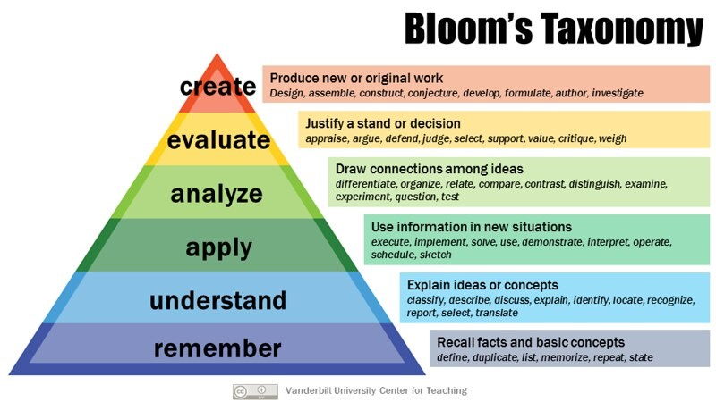

**Why is Flipped Learning important?**

Flipped learning places students as active participants in their own learning and provides several benefits. First, when students have access to direct instruction at home, whether through video or text, they can review the concept multiple times at their own pace. Secondly, when class time is spent having students apply, analyze, evaluate, and create, the instructor can observe, informally assess, and scaffold as needed. Finally, one of the greatest benefits of flipped learning is increased student engagement. Flipped learning has been shown to increase student attendance and increase motivation, which can be a key element in the language acquisition process.

**Three tips for flipping your class**

If you are new to flipped learning, I’d like to provide you with three tips to get you started:

1. Start small. You don’t need to flip your entire class overnight. Start with just one lesson and then build from there.
2. Expect some resistance. Occasionally, students might be initially resistant to this approach, especially those who are used to teacher-centered learning environments. They may need time to see the value in this pedagogical approach.
3. Choose textbooks with digital tools. Many publishers now include online materials with their textbooks and these can be used to move some of the direct instruction out of the class.

It is not difficult to see why flipped learning has taken language classrooms by storm. As language instructors we never feel there is enough time to teach, so moving direct instruction out of the class frees up time to focus on interactive (and fun) activities that contribute to your student’s language development. If you’d like more information on flipping your classroom, be sure to check out the [Flipped Learning Network](https://flippedlearning.org/), a non-profit online community for educators who are interested in learning more about flipped learning.